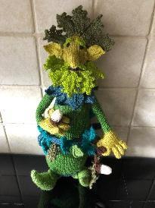

BURPHAM EVENING WI NEWSLETTER JANUARY 2026 Website: www.burphamevewi.co.uk
Facebook : https://www.facebook.com/burpham.eveningwi

COMMITTEE
Julie Beattie - President - presidentbewi@surreyfedwi.org.uk
Glenda Mogg - Secretary - secretarybewi@surreyfedwi.org.uk
Liz Hyland - Treasurer -
treasurerbewi@surreyfedwi.org.uk
Heather Harkman, Steph Goodall, Wendy Wickwar,
Cheryl Veldsman

BEWI UPCOMING LIVE EVENTS
JANUARY MEETING - Tuesday 20th January
RESOLUTIONS We will discuss and vote for the 2026 resolutions
Refreshments: Dora Pearce, Penny Kelly, Frances Jones
BOOK CLUB 2 – Thursday, 22nd January Host - Glenda - Hamnet by Maggie O’Farrell
BOOK CLUB 1 – Tuesday, 27th January Host – Carol – Look in the Mirror by Catherine Steadman
JANUARY COFFEE & CHAT - Thursday 15th January, Millmead Church, Guildford 10.30am - 12 Noon.
NEW YEAR LUNCH - Friday 23rd January at King William 4th - 12 for 12.30. BOARD
KNITTERS Thursday, 29th January 1pm at Glenda’s
SHUFFLEBOARD – Tuesday, 3rd February at The Stoke Pub, lunch 12.30, game to start at 1.30 BOARD
FEBRUARY COFFEE AND CHAT – Friday, 13th February at Edwins at Mayford 10.30 -12 noon
ART EVENING at ART & GRIND – Friday, 27th February –
6-8.30pm Landscape collage £35 per person
QUEEN’S CLOTHES EXHIBITION


Friday 3rd July 2026 11.30am Entrance Cost £20. We have purchased 25 tickets - 5 places still available.

RECENT AND UPCOMING BIRTHDAYS

Theresa Brown 11/1, Jane Regan 30/1, Annie Hawthorne 9/2, Liz Wix 9/2,



SFWI UPCOMING LIVE EVENTS
Please see January SWIN for full list of events but you may be interested in the above event
TO BOOK ONTO ANY OF THE SFWI EVENTS YOU NEED TO CLICK ON THE LINK ON THE ADVERTISEMENT IN THE ONLINE SWIN. THIS WILL TAKE YOU TO THE BOOKING FORM AND THE PAGE TO PAY FOR THE EVENT

LINK TO SWIN ON WEBSITE - We have added a link to the SWIN on Burpham WI website, it’s right at the bottom - https://www.burphamevewi.co.uk/Links/



THE CHANCE TO WIN £25,000 BY SUPPORTING BURPHAM WI VIA THE WI LOTTERY?
Each month Burpham Evening WI receives money from The WI Lottery which will increase the more tickets we sell!
We plan to use these funds to contribute towards the cost of events.
It is a weekly draw and tickets cost £1. Below is the link to our page -
https://www.thewilottery.co.uk/support/burpham-evening-wi
So far, we have raised £239.60 and we have only sold 23 tickets. In the January draw you can win £1000 Aldi gift card.
WI LEARNING HUB IS CHANGING ITS NAME TO VIA
VIA launches on 9th February 2026 and all members will have their personalised user profile automatically created. To ensure this happens your email address must be correct on the WI MCS (Membership Communication System) so the question is:
DO YOU RECEIVE THE SWIN BY EMAIL ON 1ST OF THE MONTH?
If so, your email is correct; if not, please let Liz know so we can amend our records.

CAN YOU HELP OUR WI?
We are looking for members to help with jobs that do not involve being on the committee. Could you organise a coffee morning, thank the speaker, buy the refreshments each month, be a buddy to a new member or anything else? Please speak to a committee member.
LIFTS TO OUR MEETINGS IN WINTER MONTHS.
Some of our members are unhappy driving in the winter months. Could you offer someone a lift? If you could, please put your name on the board at the meeting.


SCAM ALERT
Would you recognise a fake
email from a real one? Keep
up to date with the latest
scams by signing up to the
Which? scam alert.
Click the link below.
https://www.which.co.uk/news/article/the-latest-scam-alerts-from-which-aBRLy2b02WkC

IS YOUR EMERGENCY INFORMATION ON YOUR PHONE?
Surrey Fed has provided a document to help you set up your emergency contacts on your phone.
See the link below.
https://surreyfedwi.org.uk/wp-content/uploads/2025/11/How-to-Set-Up-Your-Emergency-Information.pdf

BAYEUX TAPESTRY
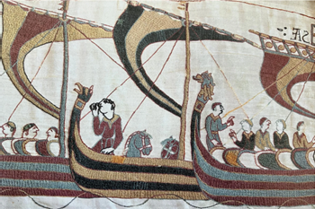

You might have seen from our 2026 programme that we are visiting the copy of the Bayeux Tapestry at Reading.
As part of BCA’s series of winter lectures there will be a talk on the Bayeux Tapestry in the village hall on
Friday, 23rd January at 7.30pm.

SOME RECENT PICTURES

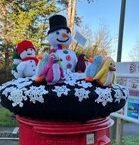

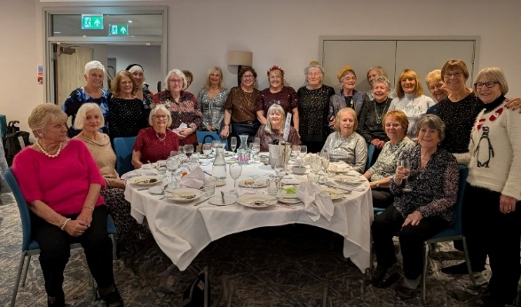

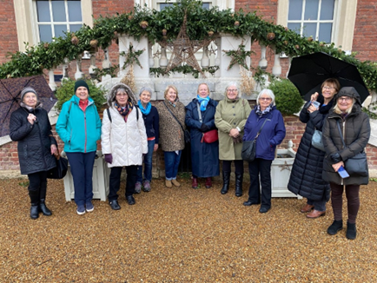

hHAM

